
RAMAIAH
INSTITUTE OF TECHNOLOGY
USN | 1 | M | S

(Autonomous Institute, Affiliated to VTU)
(Approved by AICTE, New Delhi & Govt. of Karnataka) Accredited by NBA & NAAC with ‘A’ Grade

MAKEUP EXAMINATIONS – FEBRUARY 2018

Course & Branch | : | B.E. : Common to all branches | Semester | : | I
Subject | : | Engineering Mathematics | Max. Marks | : | 100
Subject Code | : | MAT101 | Duration | : | 3 Hrs

Instructions to the Candidates:
- Answer one full question from each unit.

 |  | UNIT- I
1. | a) | Write the expression for length of the perpendicular from pole to the tangent. | CO1 | (02)
 | b) | Show that the circle 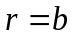 cuts the curve 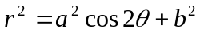 at an angle 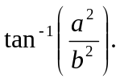 | CO1 | (04)
 | c) | Prove that the functions 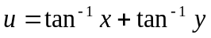 and 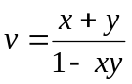 are functionally dependent using the concept of Jacobians. Also express in terms of . | CO1 | (07)
 | d) | If 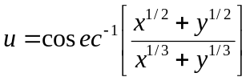 then show that  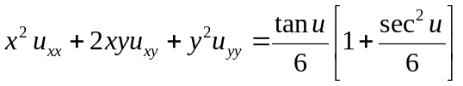 | CO1 | (07)
2. | a) | State Euler’s theorem on homogeneous functions of two and three independent variables. | CO1 | (02)
 | b) | Prove that the curves 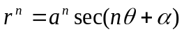 and 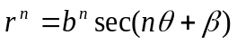 intersect at an angle which is independent of 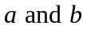. | CO1 | (04)
 | c) | Show that the pedal equation of the curve 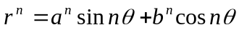 is 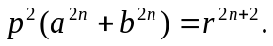 | CO1 | (07)
 | d) | If 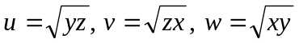 and 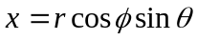, 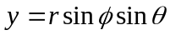, 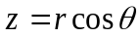 then find 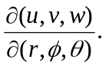 | CO1 | (07)
 |  | UNIT- II
3. | a) | Write any two properties to trace a polar curve. | CO2 | (02)
 | b) | By differentiating under the integral sign evaluate:  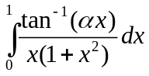. | CO2 | (04)
 | c) | Determine the common area between:  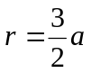 and 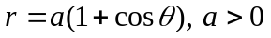. | CO2 | (07)
 | d) | Trace the curve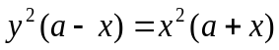. | CO2 | (07)
4. | a) | Explain the rule of differentiation under the integral sign. | CO2 | (02)
 | b) | Find the asymptote of the curve 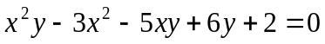, if any. | CO2 | (04)
 | c) | Find the surface area of the solid obtained when the cycloid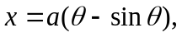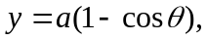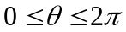is rotated about its base. | CO2 | (07)
 | d) | Prove that: 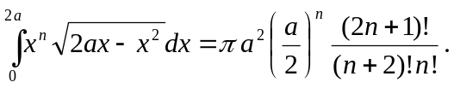 | CO2 | (07)
 |  | UNIT- III
5. | a) | Define double integral of f(x,y) as a limit of sum. | CO3 | (02)
 | b) | Evaluate: 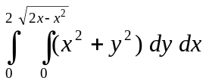 by changing into polar coordinates. | CO3 | (04)
 | c) | Evaluate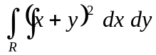 where is the parallelogram in the 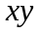-plane with vertices 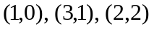and 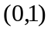by using the transformations 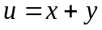 and 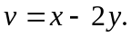 | CO3 | (07)
 | d) | By changing the order of integration, evaluate :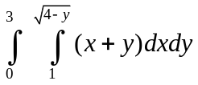. | CO3 | (07)
6. | a) | Write the relation between Cartesian and cylindrical coordinates system. | CO3 | (02)
 | b) | Using double integration, find the area enclosed by the curves 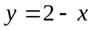 and 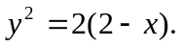 | CO3 | (04)
 | c) | Find the volume of the ellipsoid 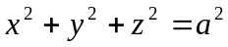 using triple integration. | CO3 | (07)
 | d) | Evaluate 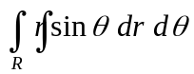over the cardioid 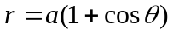 above the initial line. | CO3 | (07)
 |  | UNIT- IV
7. | a) | At any point on the curve 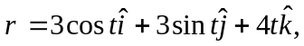 find unit tangent vector. | CO4 | (02)
 | b) | Show that 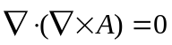 | CO4 | (04)
 | c) | Find the values of and , so that the surfaces 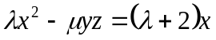and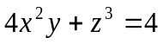 may intersect orthogonally at the point (1,-1, 2). | CO4 | (07)
 | d) | Show that 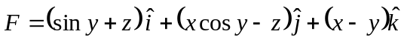 is irrotational. Also find a scalar function such that 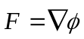. | CO4 | (07)
8. | a) | Give physical interpretation of divergence of a vector. | CO4 | (02)
 | b) | If 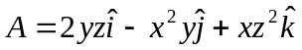then find 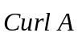 and 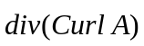. | CO4 | (04)
 | c) | A particle moves along the curve 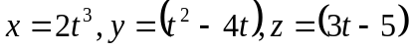 where is time. Find the components of velocity and acceleration at 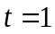 in the direction of 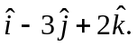 | CO4 | (07)
 | d) | Prove that 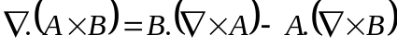. | CO4 | (07)
 |  | UNIT- V
9. | a) | State Stoke’s theorem. | CO5 | (02)
 | b) | Evaluate 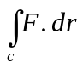, where 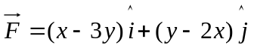 and is the closed curve in the 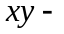plane , 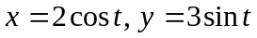 from 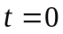 to 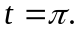 | CO5 | (04)
 | c) | Using Divergence theorem, evaluate 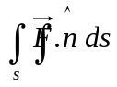 where 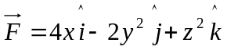 and is the surface bounded by the region 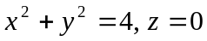and 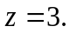 | CO5 | (07)
 | d) | Using Green’s theorem, evaluate 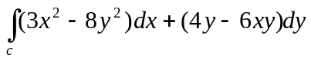 where is the region bounded by 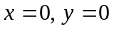 and 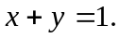 | CO5 | (07)
10. | a) | If 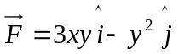 then evaluate 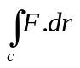 where is the curve 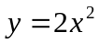in the - plane from 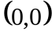 to 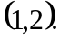 | CO5 | (02)
 | b) | Using Gauss Divergence theorem, evaluate 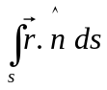 where is the surface of the sphere 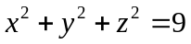. | CO5 | (04)
 | c) | Using Stoke’s theorem, evaluate 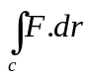 where 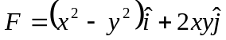  and c is taken round the rectangle bounded by the lines 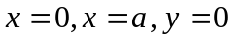 and 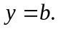 | CO5 | (07)
 | d) | State and Prove Green’s theorem in a plane. | CO5 | (07)

****************

